# Sprint 3 Plan

**GOAL**: The goal for this sprint is to get the website to be hosted, and complete the full fledged MVP, make the site look nice.

**User Stories**

Must Have

As a user of the website, I want to be able to access my neural networks across multiple machines.

Task 1: heroku spike

Task 2: set up heroku

As a user of the website, I want a wide array of layers and activation functions to choose from

Task 1: Create model for interface between javascript and python

Task 2: Add all the other layers, activation functions, optimizers, and loss functions to Tensorflow

code generation

Task 3: Add all the other layers, activation functions, optimizers, and loss functions to pytorch

code generation

Task 4: Design and implement the visual appearance of layers and activation functions.

Task 5: Add all of the layers and activation functions to the add operator screen

Task 6: Generalize the edit operator screen.

As a user of the website, I want the experience of creating the website to be simple and intuitive

Task 1: Implement Tutorial

Task 2: restrict what can be added to edit operator text inputs

As a user of the website, I want the model I create to be run on a real dataset, so I can get a sense of the efficiency of my model

Task 1: Figure out how to use google colab api

Task 2: create frontend view of running optimization

**TEAM ROLES**

Nicolas Ayala PO, SM

Anish Pahilajani

Kat Negrete

Mahesh Vegiraju

Alex Hutchins

**INITIAL TASK ASSIGNMENT**

Nico: Create model for interface between javascript and python

Alex: Implement tutorial, add remove button, make edit operator screen, add new operators to UI

Kat: Add optimisers and loss functions to pytorch

Mahesh: Google Co-lab spike

Anish: Add optimisers and loss functions to tensorflow

**BURNUP CHART**

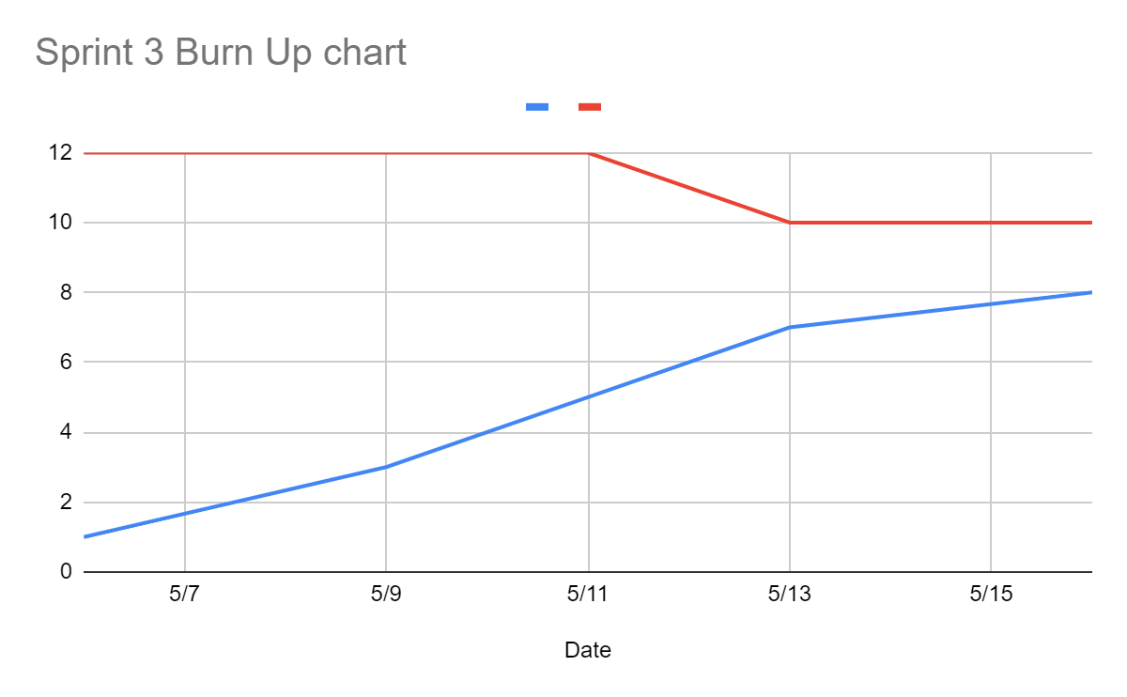

**SCRUM BOARD**

[**https://trello.com/b/0jAgTpGp/sprint-3**](https://trello.com/b/0jAgTpGp/sprint-3)

**SCRUM TIMES**

**mon-wed-fri afterclass**